**HOTEL MANAGEMENT SYSTEM**

END TERM REPORT

***by***

**JAYANT UBHA**

**ANSH TREHAN**

**RAHUL HUSSAIN**

**KASHISH AHUJA**

Section: K17KQ

Roll Number(s): 49, 51, 52, 53



**Department of Intelligent Systems**

**School of Computer Science Engineering**

**Lovely Professional University, Jalandhar**

April, 2018

**Student Declaration**

This is to declare that this report has been written by us. No part of the report is copied from other sources. All the information included from other sources have been duly acknowledged. We aver that if any part of the report is found to be copied, we shall take full responsibility of it.

Jayant Ubha

B49

Ansh Trehan

B51

Rahul Hussain

B52

Kashish Ahuja

B53

Place:

Date:

**TABLE OF CONTENTS**

**TITLE** **PAGE NO.**

1. **Introduction……………………………………………………… 5**
2. **Goals and Objective……………………………………………... 6**
3. **Description of Project…………………………………………… 7**
4. **Pictorial Representation of Website…………………………… 8**
5. **Work Division…………………………………………………… 9**
6. **Implementation of scheduled work of Project……………….... 10**
7. **Technologies and Framework Used……………………………. 15**
8. **S.W.O.T. Analysis……………………………………………….. 16**

BONAFIDE CERTIFICATE

Certified that this project report "HOTEL MANAGEMENT SYSTEM” is this bonafide work of “JAYANT UBHA, ANSH TREHAN, RAHUL HUSSAIN, KASHISH AHUJA” who carried out the project work under my supervision.

*(Signature)*

Rupinder Kaur Gill

Assistant Professor

ID-

Department of Intelligent Systems

**INTRODUCTION**

HOTEL MANAGEMENT SYSTEM is a website designed for management of a hotel. Its main aim is to computerize the traditional system of the hotel. It not only keeps the record of various people like customers, managers etc. but also reduce the extensive paper work in the present system. It makes the system more versatile and user friendly. A user is proposed with a variety of features to choose from. The system provides different package facilities to suit the customer’s needs. The user interface must be simple and easy to understand even by the common man.

The highlights that can be added to the online hotel management system are given below:

* **Access anywhere**: The online hotel reservation project can be reached at anytime and anywhere from the world with great efficiency.
* **Easy booking**: The rooms in the particular hotel can be reserved easily through this site with great expertise.
* **Hotel description**: This project will contain the room information and the location of the hotel

**Goals and Objectives**

The website interface designed focuses on following objectives:

* User interaction
* Tariff Details
* Photo gallery
* Front Office
* Login
* Payment Gateway
* Call and internet billing
* Advance Booking
* Travel Agency

**Description of the project**

The hotel website consists of following modules:

1. Homepage
   * The first page of the website
2. About Us
   * Gives brief description about the hotel
3. Rooms & Tariff
   * Shows basic rate list and policies of the hotel
4. Photo gallery
   * Gallery of photos of rooms, restaurant and others
5. Restaurant
   * Gives brief description about the restaurant in hotel
6. Contact Us
   * Contains a form to get in contact with the hotel and other communication methods
7. Login
   * To login customers to get details of their stay.
8. Booking
   * For advance booking of rooms in hotel
9. Payment
   * A payment gateway
10. Travel Agent
    * Gives brief information of travel agency in hotel
11. Call Accounting
    * Calculates bill of using calling facility of hotel
12. Internet Access and billing
    * Calculates bill of using hotel’s internet
13. Sales and catering
    * Shows the handlooms which are sold in hotel
14. Spa and health club
    * A page for spa and health club facility given by hotel.

**Pictorial Representation of the Website**

**Work Division**

The complete website consists of different webpages. We have divided the work load among four of us by dividing the webpage work in following manner:

1. Home, About Us, Login, Internet Usage & Billing
   * Ansh Trehan
2. Room & Tariff, Contact Us, Call Accounting, Travel Agency
   * Jayant Ubha
3. Photo gallery, Restaurant, Booking
   * Rahul Hussain
4. Spa & Health Club, Sales & Catering, Payment
   * Kashish Ahuja

**Implementation of scheduled work of Project**

This website can be used by a Hotel for customer’s advance booking. This website gives brief description about hotel including prices, policies and photos of rooms and hotel. The website has its own payment gateway. Customers can log in to this website or surf as a guest.

**Screenshots**

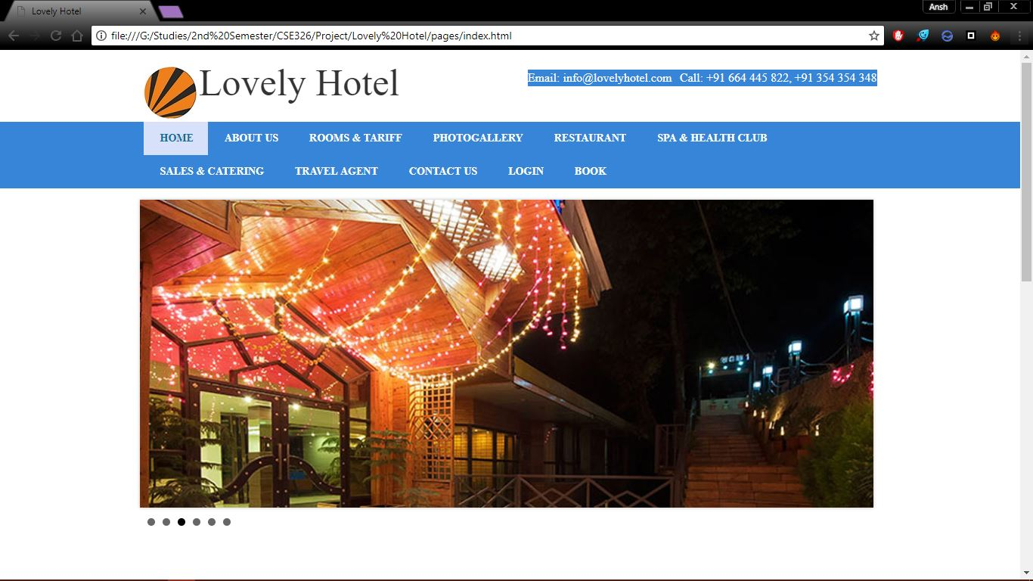

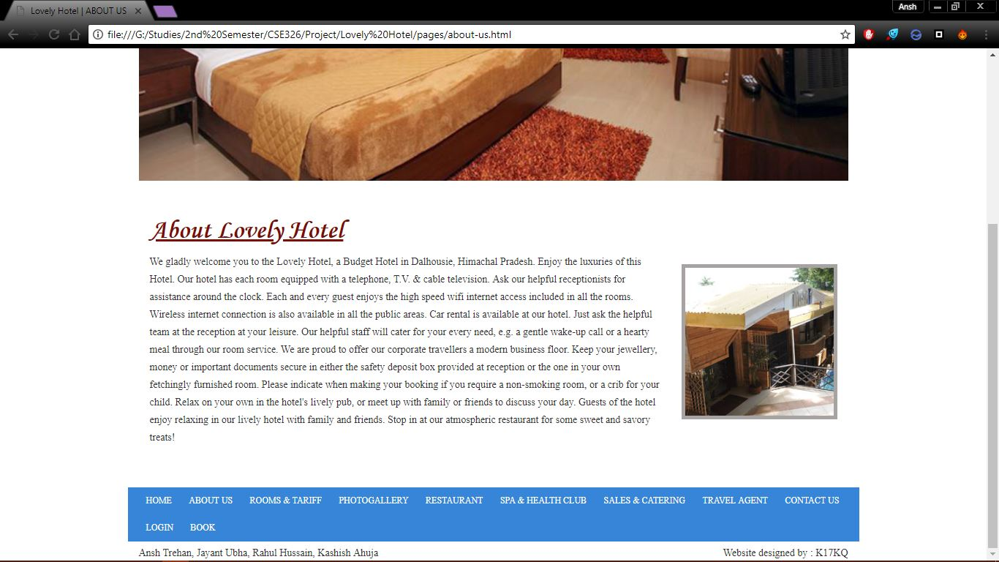

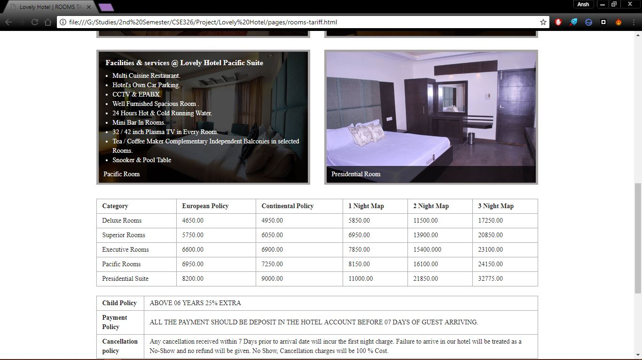

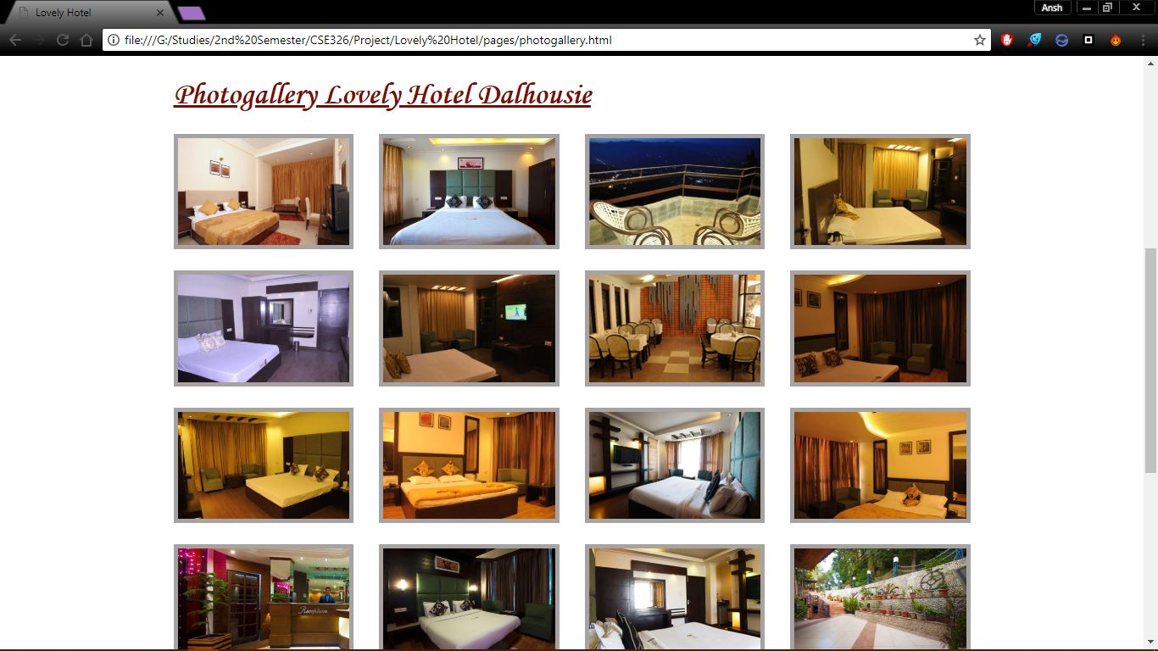

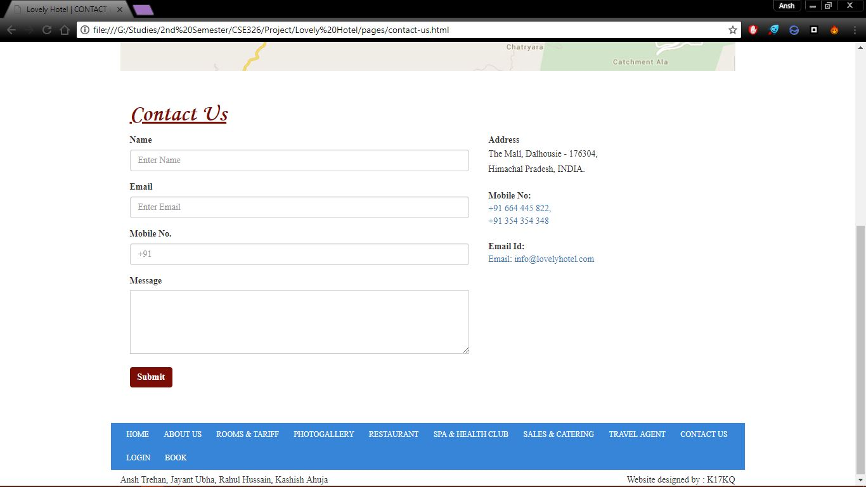

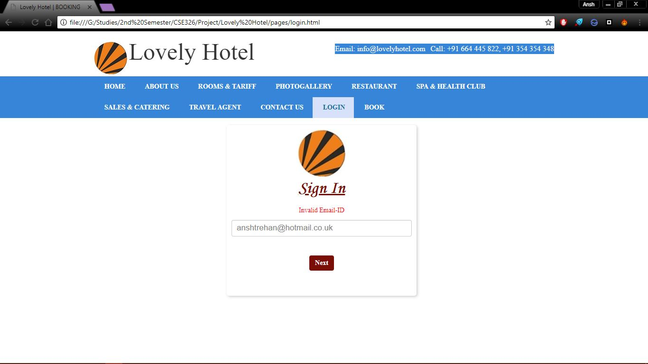

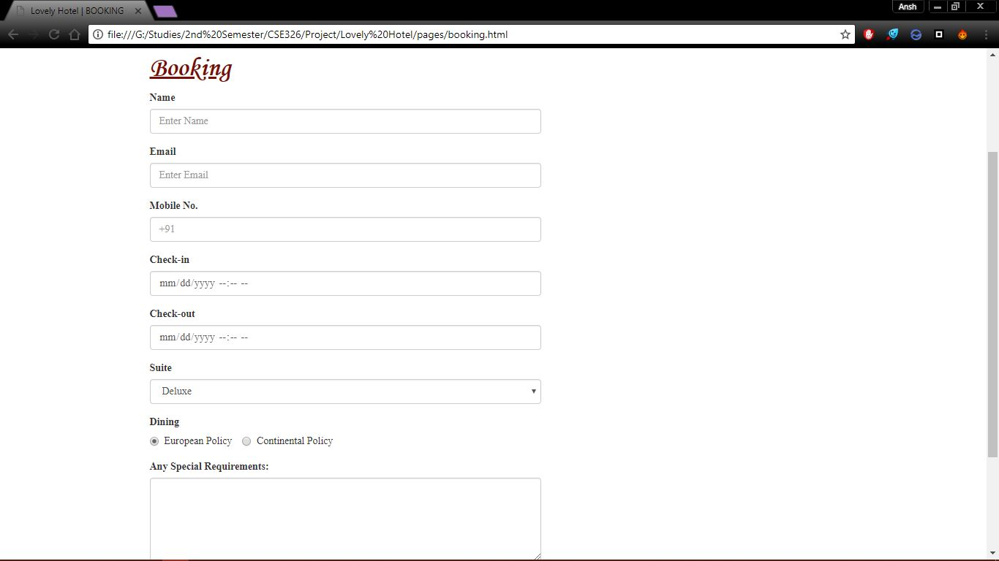

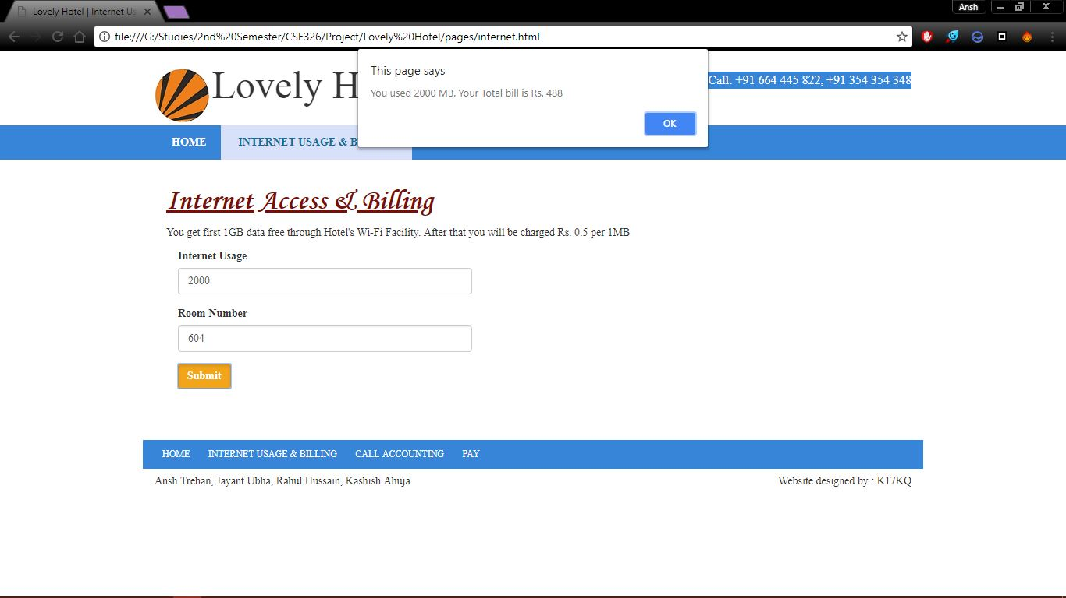

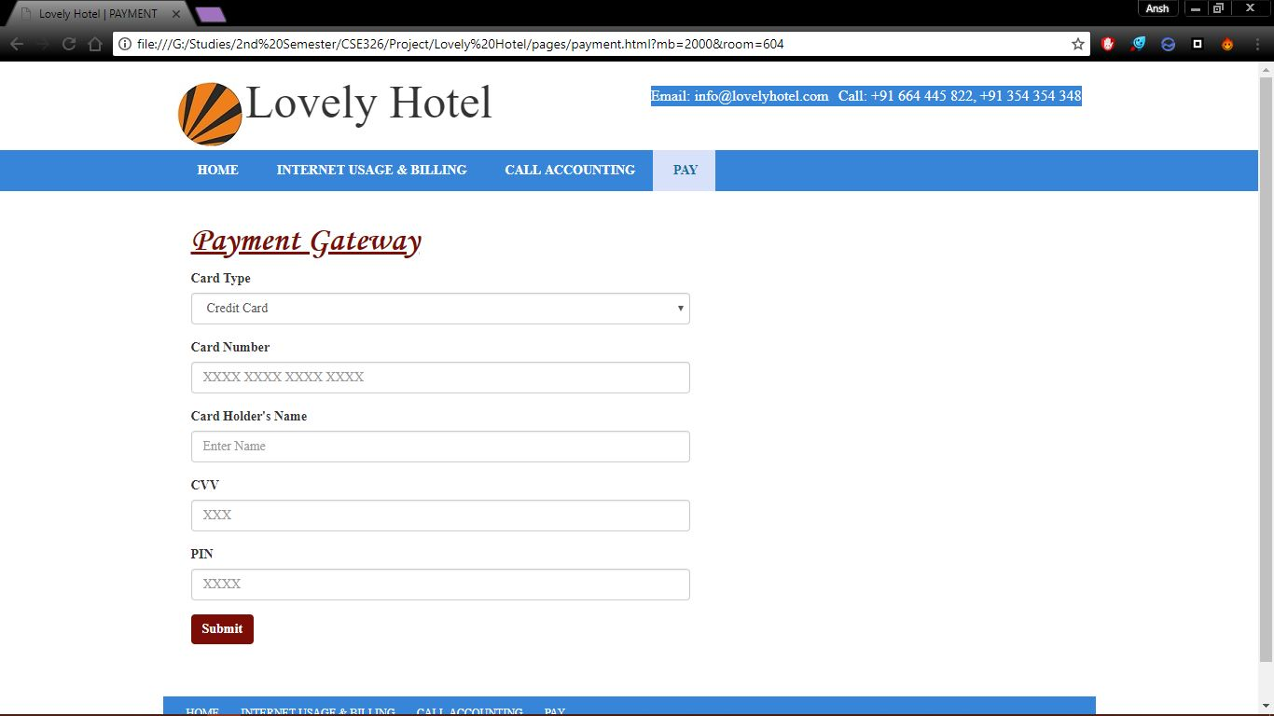

**TECHNOLOGIES AND FRAMEWORK USED IN THE PROJECT**

We have used the following technologies and frameworks to design the webpage:

**Technologies**:

* **HTML** - HTML is used to give structure to the webpage and define contents like text, tables, images and videos in the webpage.
* **CASCADING STYLE SHEET (CSS)** – It is used to make the website look appealing and attractive by applying styling to our HTML content.
* **JAVASCRIPT** - JavaScript comes into play after HTML and CSS elements are loaded in the webpage. It enables one to create dynamic content, control multimedia, animate images, etc.

**Frameworks**:

* **BOOTSTRAP** – Bootstrap is used to make the website responsive. It also helps the website to fit on a wide range of devices like desktops, tablets, smart phones accordingly.
* **BXSLIDER** – BxSlider is used to create a slider on the Home Page using jQuery.

**S.W.O.T Analysis**

As far as we will go to SWOT Analysis on Hotel Management System we must clear the meaning of SWOT. Though at the first look the word SWOT seems too simple, but it is a wide term used as S.W.O.T which contains all the necessary data or information of a Business Organization, Firm, others institutions etc.

S.W.O.T contains four different aspects in it, in which S stands for STRENTH of the concern object, W stands for WEAKNESS, O stands for OPPORTUNITY and T stands for THREATS for that concern object.

As we apply this SWOT concept on Hotel Management System we see that there is a solid strength as well as weakness of it. It has great opportunities in its circle as well as threats from other private sector efforts.

STRENGTH

1. By Hotel Management System, the traveller gets a room booked.
2. Through Hotel Management it becomes easier to connect with the travellers.
3. After Hotel booking there is No worry to find rooms later.

WEAKNESS

1. Customers aren’t satisfied with the Hotel Management System.
2. There is no proper timing of the availability of rooms.
3. The hotel bookings aren’t secured and can be hacked.

OPPORTUNITY

1. Reduction in costs of bills to increase more customers.
2. Give them good offers so that could enjoy booking their rooms.
3. They could make the webpages look more decent that to be easier for the passengers to access it.

THREATS

1. The operation is program oriented so could not be maximized.
2. Customer focus is missing and customer satisfaction is not there.